READING COMMUNITY LEARNING CENTRE

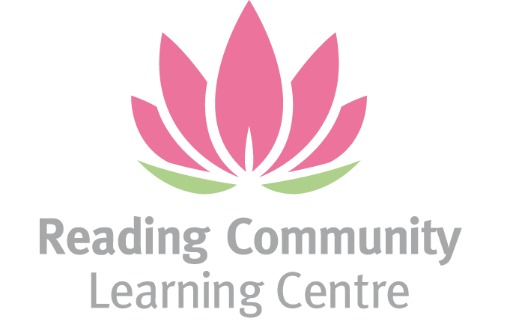

APPLICATION FOR THE POST OF CENTRE MANAGER

CONTACT DETAILS
NAME

ADDRESS & POSTCODE

TEL NO (DAY) | DAY:  EVENING:  MOBILE:
E-MAIL
NI No

Please note the following:

This post is open only to women - section 7 (2) of 1975 Sex Discrimination Act applies.

We are required to check your entitlement to work in the UK (Asylum and Immigration Act 1996). If you are shortlisted for interview, we will ask you to bring with you your original documents which prove your entitlement: e.g. passport, P45, P60 and your National Insurance number.

Do you need a work permit to work in the UK?

Yes No

If yes, please provide details ______________________________________________________

We will also ask to see evidence of the qualifications you have.

DBS Disclosure: We will need to obtain a DBS Disclosure Statement before an offer of employment can be confirmed. If you have any criminal convictions, please give details here:

CONFIRMATION AND SIGNATURE

I confirm that the details given in this application form are true and correct.

SIGNATURE DATE

1 EMPLOYMENT HISTORY
Please list your present and previous employers (continue on a separate sheet if necessary)
Employer’s name and address | Your role and responsibilities |  | Start date |  | End date
2 QUALIFICATIONS & TRAINING
Qualification held |  | Exam Board |  | Date obtained
Other relevant training |  | Awarding Body |  | Date undertaken

3 EXPERIENCE AND SKILLS
Please read the job description and person specification carefully and complete this section to provide relevant information in support of your application. (Continue on a separate sheet if necessary.)

- Describe your experience managing community centres or similar organisations.

- Outline your experience with budgeting, financial reporting, and fundraising.

- Provide an example of how you have successfully led or managed a team.

- Explain your knowledge and experience of safeguarding, Prevent, and health & safety compliance.

- Describe your experience working with vulnerable or minority communities

- MOTIVATION
- Why do you want to work at RCLC & How does this role align with your values?

e) If you are offered this post, when could you start?
Please tell us how you heard about this post (include publication)

REFEREES
(One must be your current or last employer. Please tick the box if you do not want us to contact your current employer unless you are offered the job )
Name |  | Name
Company/  organisation |  | Company/  organisation
Address |  | Address
Postcode |  | Postcode
 |  | 
e-mail |  | e-mail
Position (how known to you?) |  | Position (how known to you?)

Please sign the front page and send your completed application form by 5pm on Friday 12/9/25 to Aisha Malik (aishamalik@rclc.org.uk)

Interview date: Thursday 2/10/25

