READING COMMUNITY LEARNING CENTRE

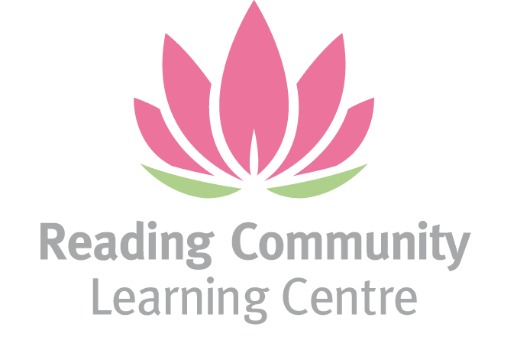

PART TIME CENTRE MANAGER

JOB ADVERT

Salary:21 hrs per week (over 3 or 4 days)
1-year fixed term contract with potential to extend if funding permits
Starting at £35,000- £38,000 per annum pro rata
This post is open to women only under the Equality Act 2010, Schedule 9, Part 1.

About Us
Reading Community Learning Centre (RCLC) is a vibrant and inclusive charity supporting migrant, refugee, and asylum-seeking, ethnic minority women in Reading. We provide a safe and welcoming space for learning, advocacy, and community building — empowering women to thrive and fostering social equality.

The Role
We’re looking for a passionate and experienced Centre Manager to lead the day-to-day operations of our Centre. This is a rewarding opportunity for a motivated woman with a strong background in community work, education, or charity management who is ready to make a meaningful impact.

Working closely with the CEO, the Centre Manager will help shape the delivery of our programmes, ensure smooth operations, and lead a team of volunteers and manage staff in the absence of the CEO.

Key Responsibilities

- Oversee the safe and inclusive daily operations of the Centre

- Support strategic planning and policy implementation

- Manage facilities and ensure health & safety compliance

- Coordinate learning programmes, outreach events, and community activities

- Maintain admin systems and contribute to financial oversight

- Build and manage external partnerships

- Recruit, train, and support volunteers

What We’re Looking For

- Proven experience in centre/office/facilities/charity administration

- Knowledge of safeguarding, equality, data protection, and Prevent duties

- Strong communication and organisational skills

- Experience managing teams in educational or community settings

- A deep commitment to empowering women and marginalised groups

What We Offer

- Annual Salary of £21,000–£22,800 (based on 0.6 FTE)

- 28 days full time equivalent annual leave (17 days if working 21 hours per week)

- Pension scheme via The People’s Pension

- Flexible working (some work-from-home)

- A supportive, purpose-driven environment

How to Apply

Closing date for applications: Friday 12/9/25 at 5pm

Interview date: Thursday 2/10/25

For an application pack, please email Hema on rclcinfo@yahoo.co.uk or go to our website: www.rclc.org.uk

