READING COMMUNITY LEARNING CENTRE
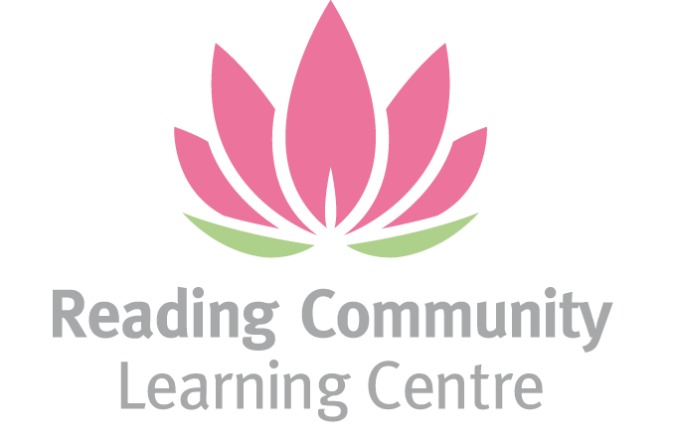

CENTRE MANAGER
JOB DESCRIPTION

Job Title: Centre Manager
Hours: 21 hours per week (working days 3 or 4 days)
Salary: £35,000 - £38,000 per annum pro rata (Actual salary: approx. £21,000 – £22,800 based on 3 days/week or 0.6 FTE)
Location: Reading Community Learning Centre, 94 London Street, RG1 4SJ with some work from home flexibility
Contract: 1-year fixed term with potential to extend if funding permits (with review at 6 months)
Reports to: CEO

This post is open only to women - section 7 (2) of 1975 Sex Discrimination Act applies

About Us
RCLC is a vibrant charity dedicated to supporting and empowering refugee, asylum-seeking, and ethnic minority women in Reading. We provide a safe, welcoming space for learning, advocacy, and personal growth. Through our outreach, education, and social programmes, we aim to foster equality, reduce isolation, and build confidence in the women we serve.

About the Role
We are seeking a motivated and experienced female Centre Manager to play a key leadership role in our organisation. This part-time position is ideal for someone who is passionate about making a difference and has strong organisational and leadership skills.

You’ll be responsible for overseeing the daily operations of the Centre, ensuring it runs smoothly, safely, and in line with our values. Working closely with the CEO, you will also contribute to strategic planning and the delivery of impactful adult learning and community programmes.

Key Responsibilities
- Oversee the day-to-day running of the Centre, ensuring a safe, inclusive, and well-maintained environment.
- Support the CEO with strategic planning, staff and volunteer coordination, and policy development.
- Manage facilities, including contracts, repairs, and health & safety compliance.
- Coordinate educational programmes, events, and outreach activities.
- Maintain administrative systems, track budgets, and assist with financial oversight.
- Represent RCLC in external partnerships, building relationships that enhance our services and help secure funding.
- Lead and manage volunteer recruitment, induction, training, and support, upholding RCLC’s quality standards.

Person Specification
Essential
- Proven experience in administration, facilities, or charity centre management.
- Strong understanding of safeguarding, data protection, equality, and Prevent responsibilities.
- Excellent organisational and communication skills.
- Experience managing staff and volunteers in a community or educational context.
- A genuine commitment to empowering women and supporting marginalised communities.

Benefits
- Generous annual leave allowance: 28 days full time equivalent annual leave (17 days if working 21 hours per week)
- Pension scheme via The People’s Pension (subject to eligibility).
- A supportive, mission-driven working environment where your work makes a real difference.

